Hi class,

Please find following as some instructions and guidelines for the course.

* **DEADLINE for assignments:**
  + Your assignments deadlines are due ﻿on Tuesday 5:00 pm ﻿before class. ﻿﻿﻿﻿﻿﻿﻿﻿﻿﻿﻿﻿
* **PYTHON version for assignments:**
  + Python 3.6 ﻿﻿﻿﻿﻿﻿﻿﻿﻿﻿﻿﻿
* **GitHub ACCOUNT and class git repository access:**
  + I have added most of you into the git repository of <https://github.com/neuniversity/ALY6140>
  + In case if you are not a member of it or don't know how to access to it, please:
    - 1- create a Github Account (https://github.com/) using your Northeastern email address
    - 2- send me your github ID to me by email at m.ziyadi@northeastern.edu
    - 3- I will add you to the repository and you should be able to access to the material
  + You can also find very useful information about Git in the following website:
    - <https://git-scm.com/book/en/v1/Getting-Started>
    - HINT: you don’t need to know the detail of Git, you can follow the steps below and you will be fine for this course.
* **INSTRUCTIONS on creating a local repository and your own branch:**

Most of you were able to create a local repository and your own branch on github.

In case if you have not done it please follow the steps below:

* + - make sure that you have "git" installed on your computer
  + If it is not installed, you can install it through the steps in:
    - <https://git-scm.com/book/en/v2/Getting-Started-Installing-Git>
    - Open a command line on Windows or terminal in Mac and
  + HINT: don't use Anaconda Command Prompt for the git. These are two different platforms.
    - Go to a directory or folder through command line that you want to have your repository located.
  + You can use the following code to move around the directories in command line
    - ls (in Mac) or dir (in windows)
    - cd “your folders”
    - cd ..
  + In case if you don't know how to work in command line please refer to
    - * + <https://www.dummies.com/computers/macs/mac-operating-systems/how-to-use-basic-unix-commands-to-work-in-terminal-on-your-mac/>
        + <https://www.cs.princeton.edu/courses/archive/spr05/cos126/cmd-prompt.html>
    - Inside command/terminal window and in your desired directory, create a repository using following line:
  + git clone https://github.com/neuniversity/ALY6140.git
    - HINT: You might face with username password required. Use the same username password that you created the github account.
    - HINT: when you type your password, it might not show it because of the security. But, no worries, just type it as it is without any extra character/space/etc. and then press enter. It should work
    - HINT: To reduce this user/pass entry from your next steps you can set up your user pass through the following lines in the command/terminal line:
      * git config --global user.name "your username"
      * git config --global user.password "your password"
  + after the cloning is done got to the directory using the following line:
    - cd ALY6140
  + type the following lines in the command/terminal line to create your own git branch.
    - git checkout -b yourfirstname_yourlastname
  + Now you have your own repository and you can make sure it by following line in the terminal/command window:
    - git branch
  + You can always go to your branch through the following command:
    - git checkout yourfirstname_yourlastname
* **After you cloned the repository and created your own branch,**
  + open the folder (not in command line necessarily) that you created did the cloning in. You should be able to see your first assignment folder and file similar to the following figure. HINT: Assignment 1 is also available through blackboard.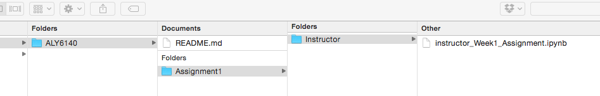
  + Now, you can start working on the assignment and complete it.
  + After you completed the assignment, please put it in a separate folder with the name of “yourfirstname_yourlastname” under Assignmnet1 folder. Also, please change the filename of the assignment to “yourfirstname_yourlastname_Week1_Assignment.ipynb”
  + After these step, your local machine directory should look like:

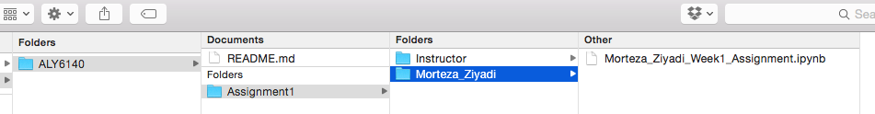

* + As you see, I have created my own folder with my own assignment name
  + HINT: please avoid using “space” in your di/folder naming. It is much easier to use “_” for this purpose.
  + Now, your assignments are complete on your local machine and you just need to push it online to the main repository.
* **INSTRUCTIONS to PUSH your assignment to online**
  + open a command/terminal window and go to ALY6140 directory as you have done before.
    - HINT: you don’t need to create or clone again. You just need to point to the directory
  + Make sure that you are in your own branch by typing the following in the terminal/command line:
    - git checkout yourfirstname_yourlastname
    - git branch
    - git pull origin master
  + Use the following code to check the status of your branch and local
    - git status
  + Use the following line to push your code to online:
    - git add --all
    - git commit -m 'update'
    - git push origin yourfirstname_yourlastname
  + After you pushed it, you should be able to see your assignment online in your own repository similar to:

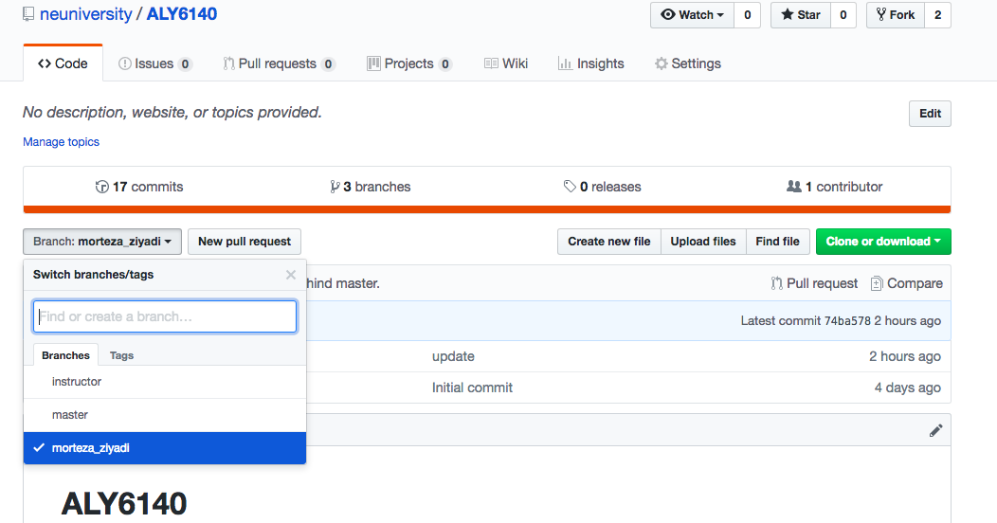

* + 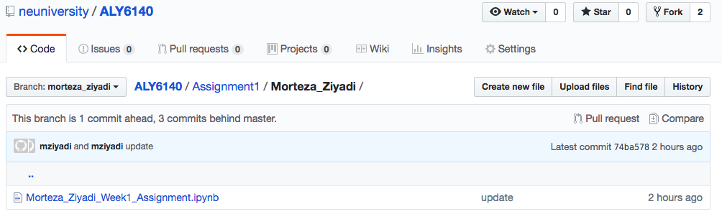
  + As you see, Branch name is morteza_ziyadi (my first/last name) and you should be able to have similar output for your own branch.
* HINT: You don’t need to push your files into the master branch. I can have access to your files through your branch.
* HINT: Please try to not to delete or add new files to the repository through other methods since it is very high possible that you will face with errors.
* HINT: Please follow the above steps accurately whenever you want to update your repository.

* INSTRUCTIONS on raising questions and engaging in the discussions:
  + You should create new issue on github in case if you face with any technical questions
  + You can create new issue by following tab in the repository:

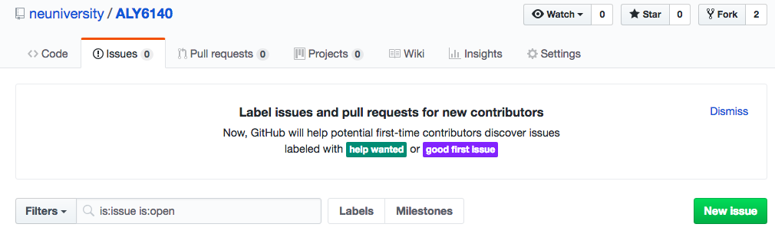

* PARTICPIATION grades:
  + Participating in answering the issues and helping your classmates as well as asking questions are considered in your participation grade.
  + For non-technical questions, you can bring it to the discussion board and being engaged in the discussion board would be part of your participation evaluation.

Best regards,

Morteza